Cloud Computing Assignment – IaaS, PaaS, SaaS and AWS EC2
TASK 2

Question 1: Identify Whether the Apps are IaaS, PaaS, or SaaS
Application | Cloud Service Model | Reason
Instagram | SaaS (Software as a Service) | Instagram is a ready-to-use application that users access through a mobile app or web browser. Users do not manage the servers or software.
Spotify | SaaS (Software as a Service) | Spotify provides music streaming directly to users over the internet. The company manages all the infrastructure and software.
Google App Engine | PaaS (Platform as a Service) | Google App Engine provides a platform where developers can build, deploy, and manage applications without worrying about server management.
Explanation:
- SaaS provides complete software over the internet for end users.
- PaaS provides a development platform for developers to build and deploy applications.
- IaaS provides virtual machines, storage, and networking that users configure themselves.

Question 2: Comparison of IaaS, PaaS, and SaaS
Feature | IaaS | PaaS | SaaS
Meaning | Provides virtual infrastructure such as servers, storage, and networking. | Provides a platform to build and deploy applications. | Provides ready-to-use software over the internet.
User Responsibility | Users manage the operating system, applications, and data. | Users manage only the application and data. | Users simply use the software without managing infrastructure.
Main Users | System Administrators and IT Engineers | Software Developers | End Users
Flexibility | High flexibility and full control. | Medium flexibility with managed infrastructure. | Least flexibility but easiest to use.
Real Example | AWS EC2 | Google App Engine | Microsoft Office 365

Question 3: Launch an EC2 Instance
I logged into the AWS Management Console and opened the Amazon EC2 Dashboard. Using the Launch Instance option, I created a new t2.micro instance with the Ubuntu Server 22.04 LTS Amazon Machine Image (AMI), which is eligible for the AWS Free Tier. After selecting the default settings, I created a key pair, launched the instance, and verified that its status changed to Running.
Screenshot
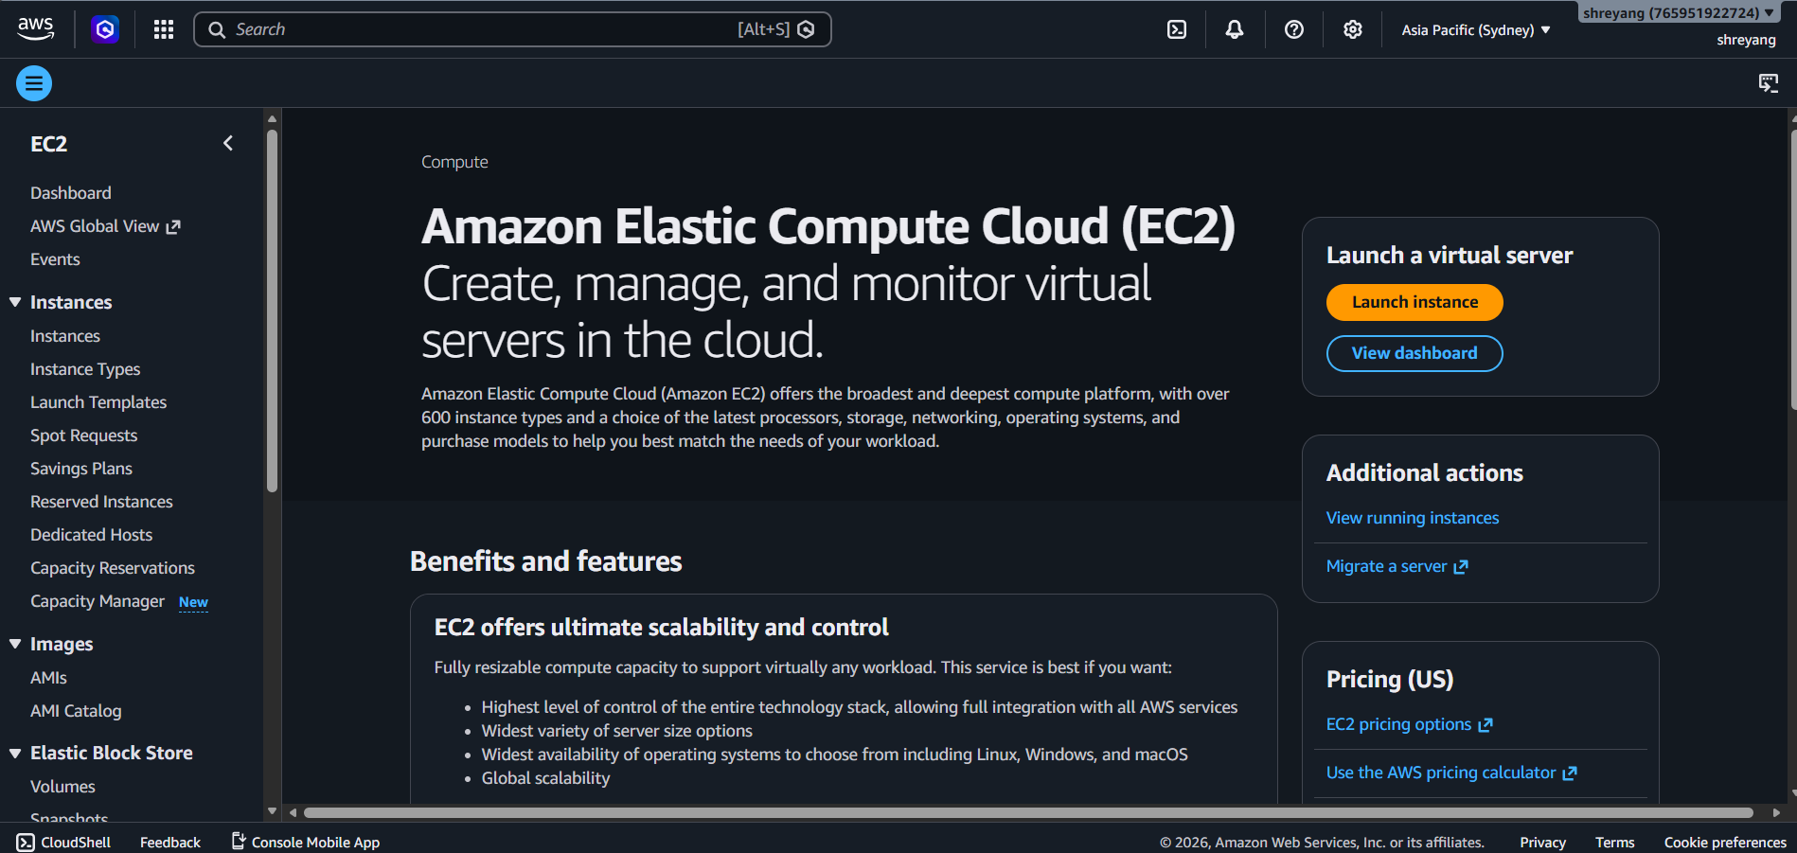

Question 4: Connect to EC2 Using SSH
Steps Followed
- Downloaded the .pem key pair during instance creation.
- Opened the terminal.
- Changed the permission of the key file using:
chmod 400 mykey.pem
- Connected to the EC2 instance using SSH:
ssh -i mykey.pem ubuntu@<Public-IP-Address>
- After logging in successfully, executed the following command:
uname -a
Command Output
(Paste the actual output from your EC2 terminal here.)
Example format:
Linux ip-172-31-xx-xx 6.x.x-aws #xx-Ubuntu SMP x86_64 GNU/Linux

Question 5: Steps to Host a Static Website on an EC2 Instance
To host a simple static website on an EC2 instance, I would follow these steps:
- Launch an Ubuntu EC2 instance and allow HTTP (Port 80) and SSH (Port 22) in the Security Group.
- Connect to the EC2 instance using SSH.
- Install the Apache web server using the following commands:
sudo apt update
sudo apt install apache2 -y
- Upload or copy the website files (HTML, CSS, JavaScript, images) into the directory:
/var/www/html/
- Open the EC2 instance's Public IP address in a web browser to verify that the website is accessible from anywhere on the internet.

Conclusion
Cloud computing offers different service models to meet different user requirements. SaaS provides ready-to-use software, PaaS offers a platform for application development, and IaaS provides virtual infrastructure with maximum flexibility. AWS EC2 is an example of IaaS that enables users to deploy servers quickly and host websites or applications efficiently.

